**DA Assignment – 3 Submission**

**Title:**  
**Supermarket Sales Dashboard**

**Submitted by:**  
**Name :** Akshitha Gurram

**Roll Number :** 22AT1A3221

**Institute Name :** G.Pullaiah College Of Engineering and Technology

**📊 Introduction**

**Objective:**  
To analyze the sales performance of a supermarket chain operating in three branches over three months using Tableau visualizations. The data contains customer demographics, purchase behavior, and sales figures.

**Tools Used:**

* Tableau Public/Desktop
* Supermarket Sales Dataset (Jan–Mar 2019)

**Dataset Source:**  
*Supermarket Sales (Kaggle / Classroom link)*

**🧹Data Cleaning in Tableau**

**Steps Performed:**

* Imported CSV dataset into Tableau
* Removed unnecessary columns:
  + *Invoice ID* (unique identifier not required for analysis)
  + *COGS* (already factored into other calculations)
  + *Date/Time columns* – not used in some dashboards
* Renamed field names for better clarity (optional)

**📉 Visualizations + Insights**

**🔷 1.Interactive Dashboard :**

**Screenshot:**

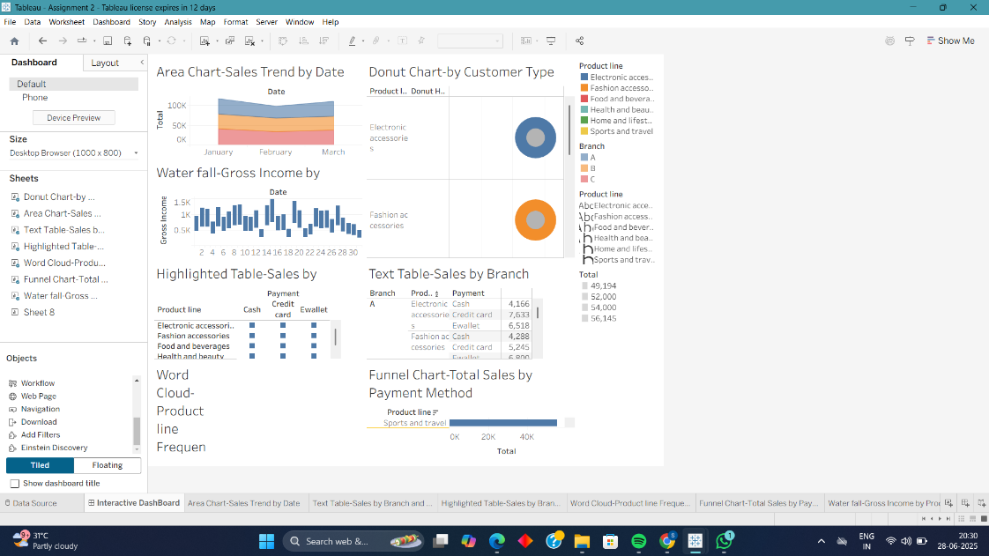

**Purpose:** **Combine multiple visualizations into a single view** to let users explore data with filters, highlights, and actions — enhancing understanding and user engagement.

📌 **Example:**

**Dashboard Title:**

**"Supermarket Sales Overview Dashboard"**

**Components (Sheets/Charts):**

1. ✅ **Donut Chart** – *Total Sales by Branch*
2. 📈 **Area Chart** – *Monthly Sales Trend*
3. 🔠 **Highlight Table** – *Gross Income by Product Line and Branch*
4. ☁️ **Word Cloud** – *Sales Volume by Product Line*

**Interactivity Features:**

* 🔍 **Dropdown Filters**
  + Add filters like Branch, Product Line, Customer Type
  + Drag to the dashboard → Click dropdown → **“Apply to all using this data source”**
* 🖱️ **Use as Filter**
  + Right-click on a chart (like Donut or Word Cloud) → **Use as Filter**
  + Clicking a segment will filter all charts
* 🌈 **Highlight Actions**
  + Dashboard → Actions → Add → Highlight
  + Highlight related values across sheets on hover
* 📆 **Date Range Slider** *(optional)*
  + Drag Invoice Date to Filter → Select range → Show filter

**Screenshot:**

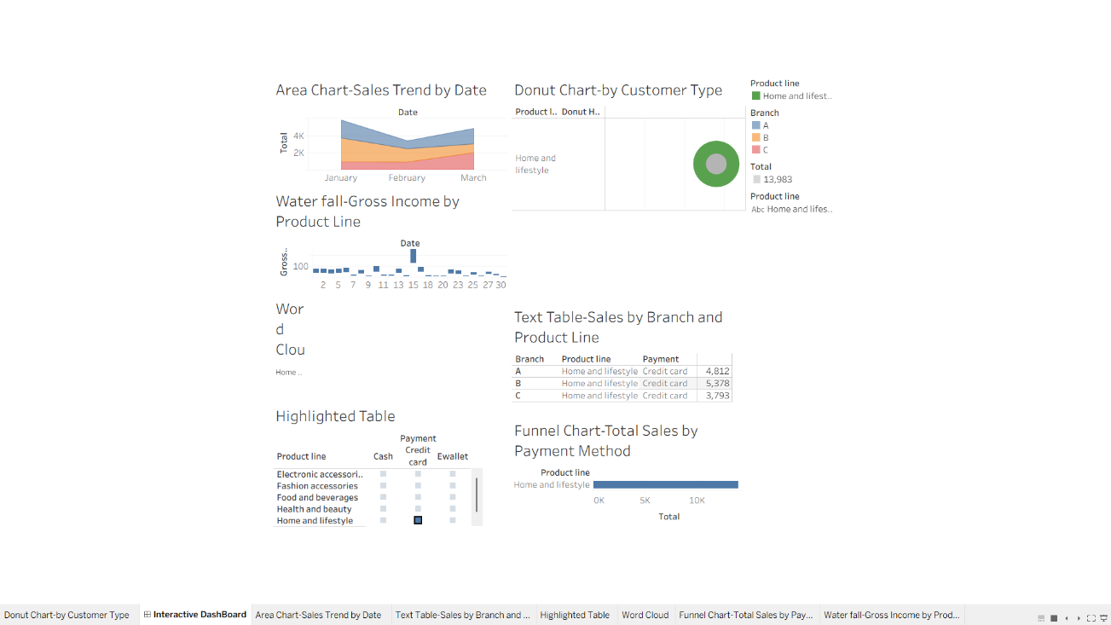**🧾Conclusion**

* Visualizations reveal valuable insights about branch performance, customer preferences, and sales behavior.
* Tableau helped quickly identify patterns such as peak sales periods, product popularity, and preferred payment methods.